- Log in to the e-service on https://goteborggsk.ist.se/goteborggsk/
- Tap/click My page and then My family.
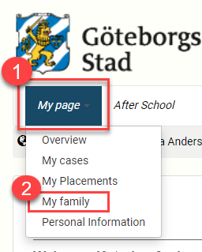
- Tap/click Terminate placement.
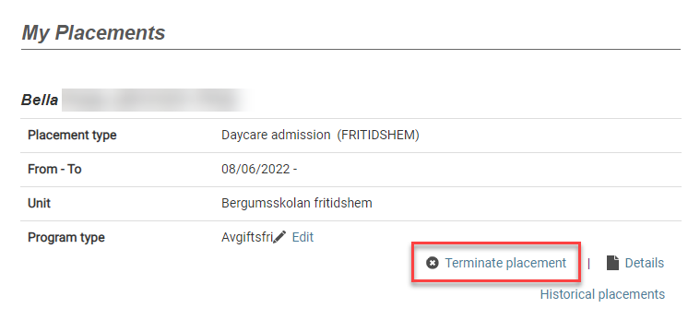

- Fill in Requested date and Reason for the cancellation, then tap/click Next. 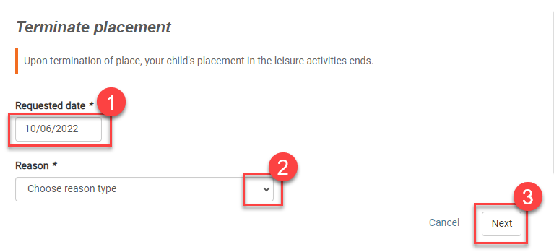
- Check that the information is correct, then tap/click Terminate placement.
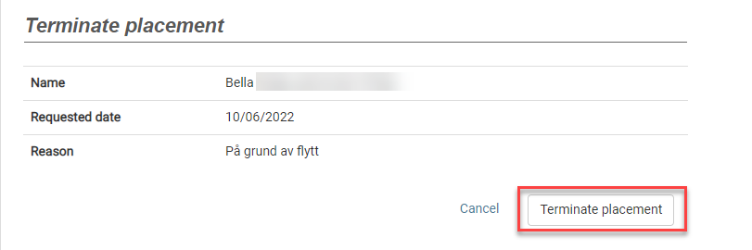

- The cancellation has been registered and sent.

Once an administrator has processed the cancellation you will also receive a confirmation via email or post, depending on whether you have registered your email address with the e-service or not.

